Project Plan
ID: 14178995
Name: Benjamin Bowden

Goal
Increase awareness of Training Zone among local residents (18–45), leading to at least a 40% increase in local customers.
The problem identified by the client is low visibility.
Therefore the website must:
- Clearly communicate who Training Zone is
- Clearly explain what services are offered
- Make the organisation visible and credible
- Encourage local residents to consider training
Success Evaluation
The website will be considered successful if:
- Local customer numbers increase by at least 40% after launch.
- There is a measurable increase in enquiries from local residents (phone, email, or form submissions).
- More users demonstrate awareness of Training Zone’s services, indicated by increased traffic to course pages.
The primary measure of success remains the 40% increase in local customers, as specified by the client.
Target Audience
- Local residents of Cairsville
- Aged 18–45
- Mainly mature-age job seekers

Site Flowchart

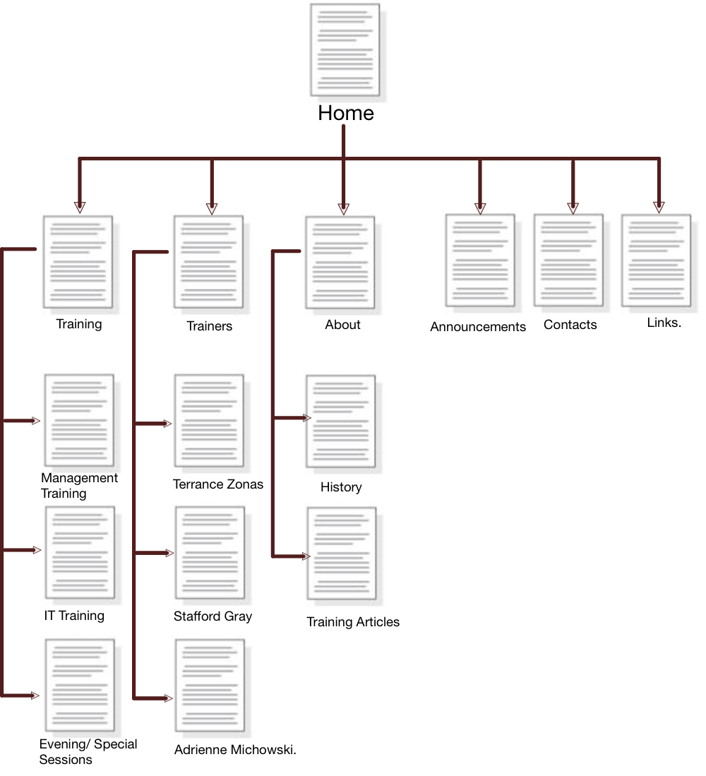

Wireframe (Home Page)

